ST.JUST-IN-PENWITH TOWN COUNCIL

Council Offices  1 Chapel Street  St Just  Penzance  Cornwall TR19 7LS  Telephone  (01736) 788412  Email:  townclerk@stjust.org |  | 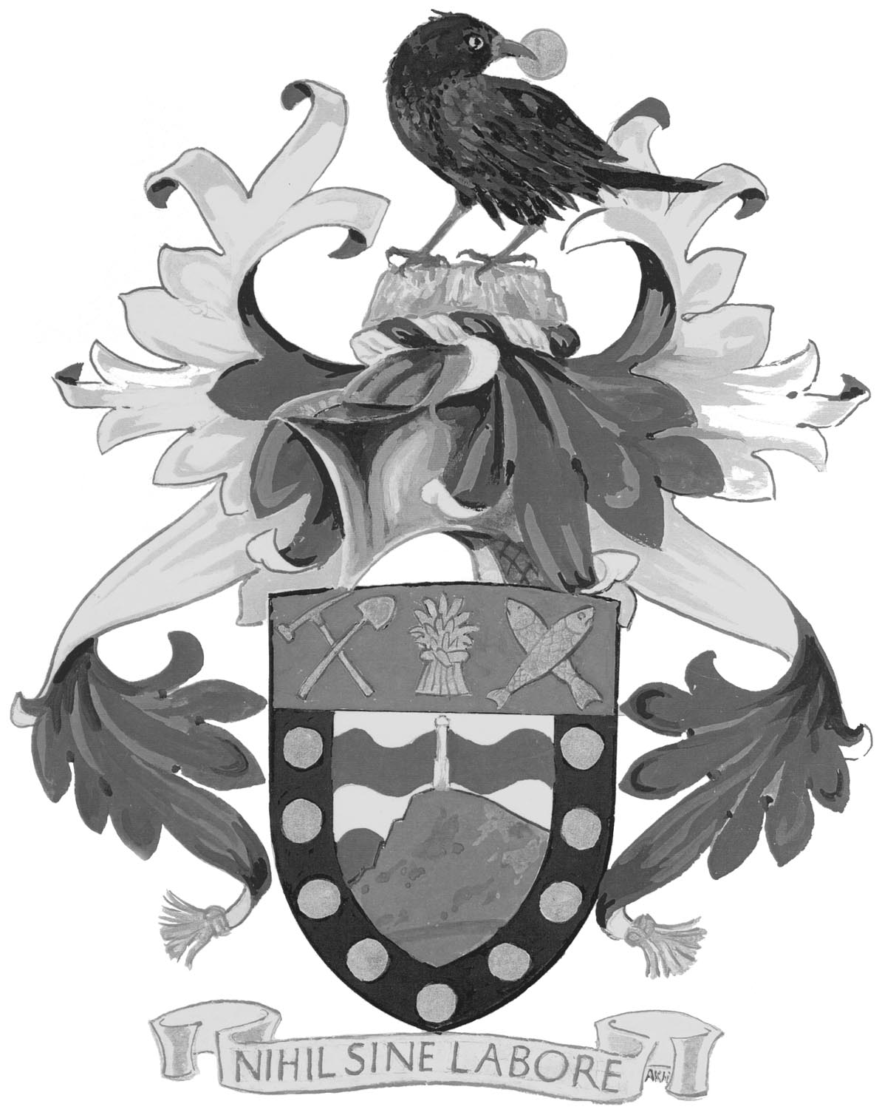
www.stjust.org

8 May 2011

ANNUAL TOWN MEETING

All electors of St Just and Pendeen are invited to the Annual Town Meeting to be held as follows:-

DATE: | MONDAY 14 MAY 2012
TIME: | 7.15 P.M.
VENUE: | COUNCIL CHAMBER, 1 CHAPEL STREET, ST JUST

Town Mayor

To:
Mayor: | Councillor M Thomas
Deputy Mayor: | Councillor Mrs S James

Councillors
Ms P S Angove | N McFadden
B F Angwin | F Morris
W F East | M Nicholls
C McClary | Mrs S Olds
K McFadden | Mr D Stevens
14 MAY 2012

AGENDA

1. | Apologies for Absence
2. | Minutes  To pass the following resolution:
 | RESOLVED – that the Mayor signs as a true and accurate record the Minutes of the Annual Town Meeting held on 9 May 2011 (copy attached).
3. | Matters Arising from the Minutes
4. | Declarations of Interest
5. | Report of the Town Council  The Town Mayor will present his annual report.
6. | Statement of Accounts for the Year Ended 31 March 2011  This item will be considered as part of the agenda for the Annual General Meeting when the Town Council will be asked to formally approve the accounts for the year ended 31 March 2012.
7. | Matters Raised by the Electorate

