ST. JUST-IN-PENWITH TOWN COUNCIL

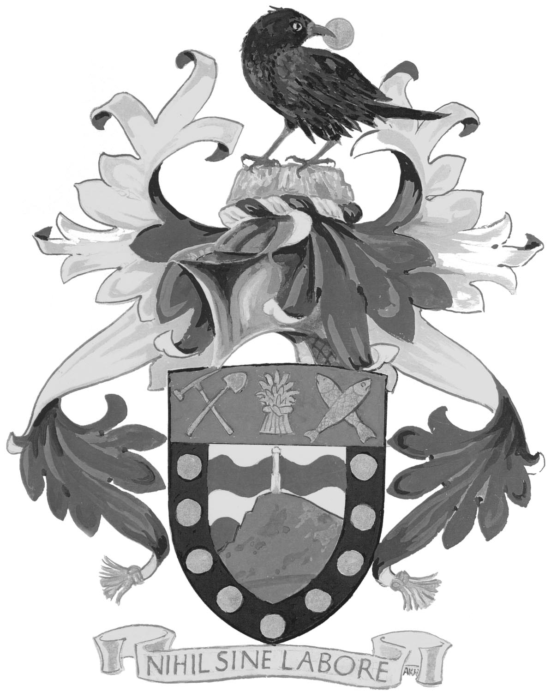

Council Offices

St Just Library and Town Council

Market Street

St Just

Penzance

Cornwall

TR19 7HX

Telephone: (01736) 788412

Email: townclerk@stjust.org

Website: www.stjust.org

Date of issue: **17 March 2021**

**Dear Councillor,**

You are hereby summoned to attend a meeting of the **Premises and Amenities Committee** to be held as follows:

**Date: Monday 22 March 2021**

**Time: 5 pm**

**Venue:** **Zoom Meeting Premises and Amenities Committee**

**Join Zoom Meeting**

For the purpose of transacting the business on the agenda below



Cas Leo

Town Clerk

**To Councillors:** Cllrs S James (Chair), J Manser, F Morris, G Prowse and D Shephard

**AGENDA**

1. Public Address at Meetings:

A period of fifteen minutes will be set aside to enable members of the public to put questions directly to the Committee. Anyone wishing to put a question to the Committee must do so by submitting it in writing **by no later than 10.00 a.m.** on the Friday preceding the meeting.

1. Apologies for absence:
2. Declarations of interest:
3. Dispensations: To consider requests for dispensation for which an application has been received by the Town Clerk.
4. Minutes:

To consider passing the following resolution: That the Chairman signs as a true and accurate record the Minutes of the Premises and Amenities Committee meeting held on 15 February 21.

1. Carnyorth Bus Shelter.

Consider the three costings provided in email.

1. Library

Review of internal and external matters. The external sign was agreed last week and was ordered, any update on likely timings. External area which would include planting, Mayors Funded Benches and flagpole costings. Latest update about damaged turf once the contractor has left site.

1. Car Parks and Toilets (update)

The Devolution and Council meeting date awaited.

1. Plain an Gwarry. Latest position to be discussed. Awaiting Nick Russell solution.
2. Any on-going matter updates.