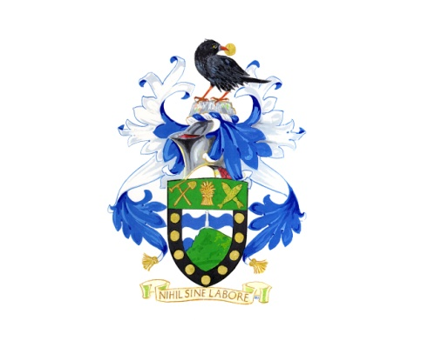

ST JUST-IN-PENWITH TOWN COUNCIL

Grant Aid Application Form

Please complete all sections and use additional sheets if necessary. If you have any questions please contact the Town Clerk, on Tel: 01736 788412 or email: townclerk@stjust.org. Post completed form to Town Clerk, St Just-in-Penwith Town Council, The Library, Council Offices, Market Street, St Just, Penzance TR19 7HX Applications may be emailed to the above address, please include accounts as scanned attachments.

1. | Name of Organisation
2. | Designated Contact Person
3. | Address for Correspondence
4. | Telephone Number
5. | Email address
6. | Bank Account Number (for use by Town Council for BACS transfers)
7. | Name of Project
8. | Description of Project
9. | Amount of grant requested
10. | Describe what the money will  be spent on?
11. | How will the project benefit the local community?
12. | Please state how you consider that you meet the conditions of the Town Council’s Grant Aid Policy?
13. | What other organisations have you approached for funding?
14. | Have you received any grant funding from St. Just Town Council during the past five years.

Please provide most recent audited accounts (tick box)

For Office Use:

Date received: | Approved: Yes / No | Date Approved:
Minute No. | Cheque No: | Signed:
Relevant Act:

